**SECTION 1:**

Write a program to perform the following operations on an array:

• Take user input to create the array

• Traverse and display all elements of the array

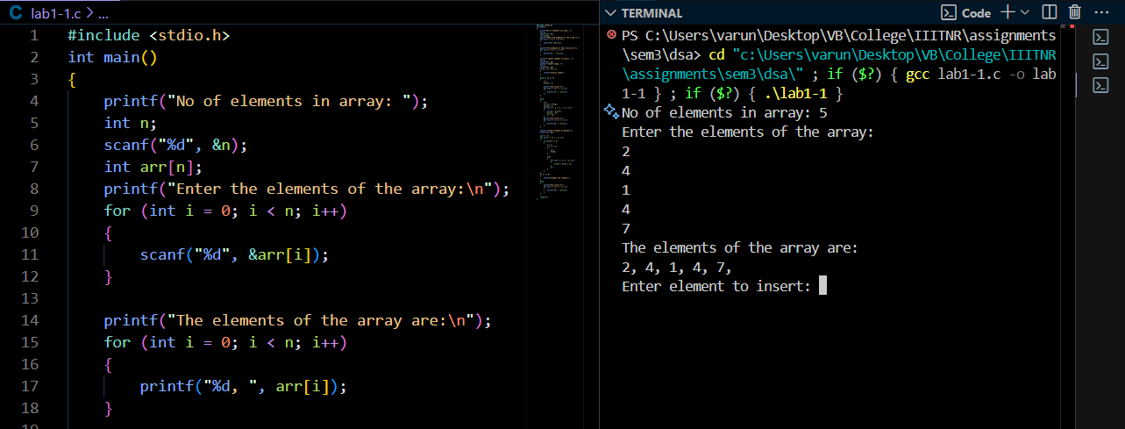

• Insert an element at a specified index

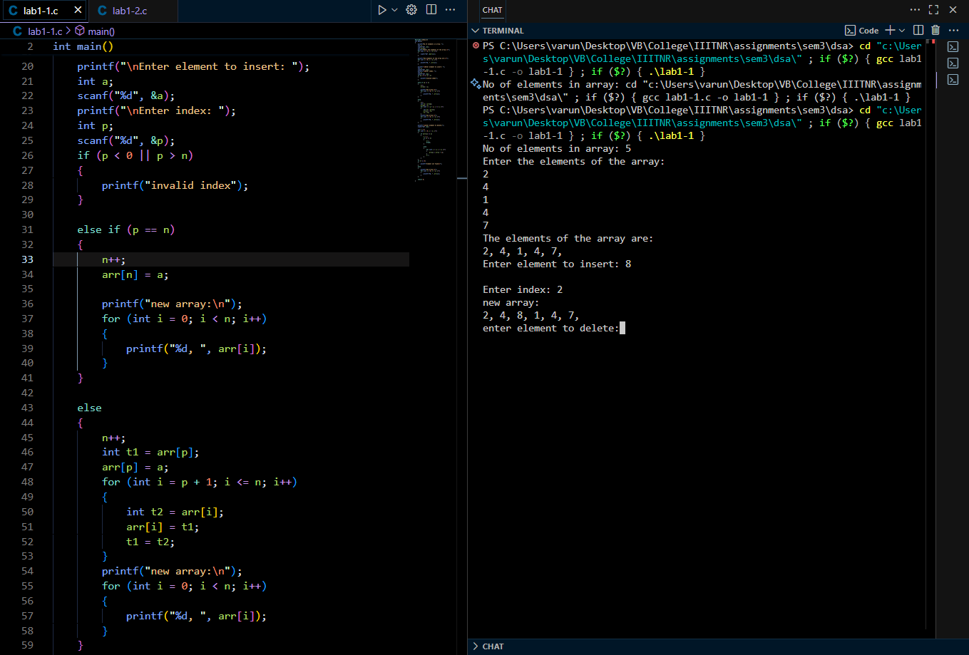

• Delete a specified element from the array

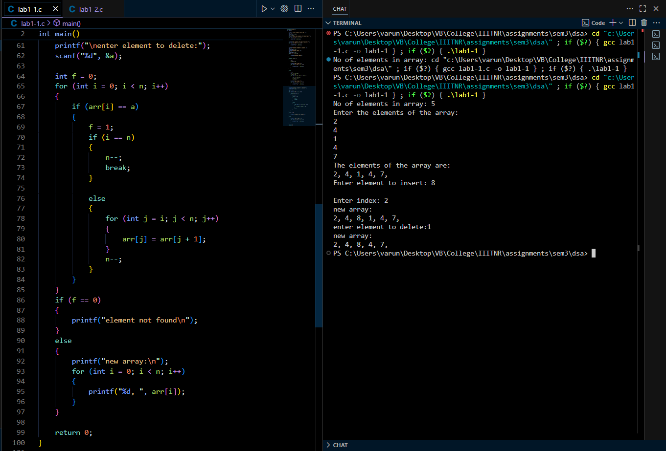

**SECTION 2:**

Implement the Bubble Sort algorithm to sort the array.

